2 Building a 3D Model Working on the Hat

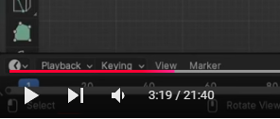

<https://www.youtube.com/watch?v=bwK7uk-A1y4>